EXPERIMENT 02
TITLE: Socket Programming using Python (TCP Client-Server)

AIM: To implement client-server communication using socket programming in Python.

OBJECTIVE:
1. To understand TCP socket programming
2. To create a server and client program
3. To establish communication between two hosts
4. To send and receive messages

SOFTWARE USED:
Oracle VirtualBox, Ubuntu 22.04, Python3

THEORY:
A socket is one endpoint of a two-way communication link between two programs running on the network. Socket programming is used for client-server communication. The server listens on a port and the client connects to it. TCP is connection-oriented and reliable.

PROCEDURE
Step 1: Create Clone (To get 2 VMs)
1. Shutdown Ubuntu VM
2. VirtualBox -> Right click Ubuntu -> Clone -> Full Clone -> Name: Ubuntu-Client
3. Start both VMs
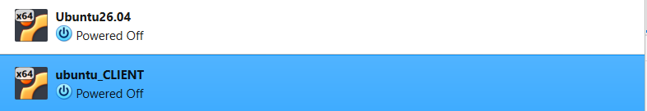
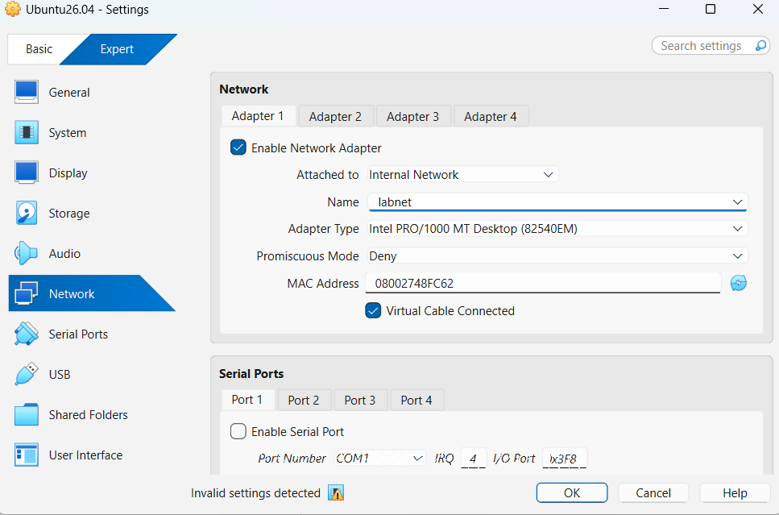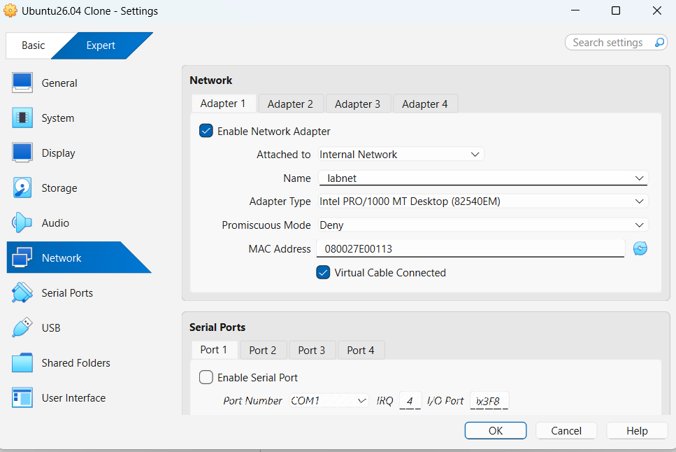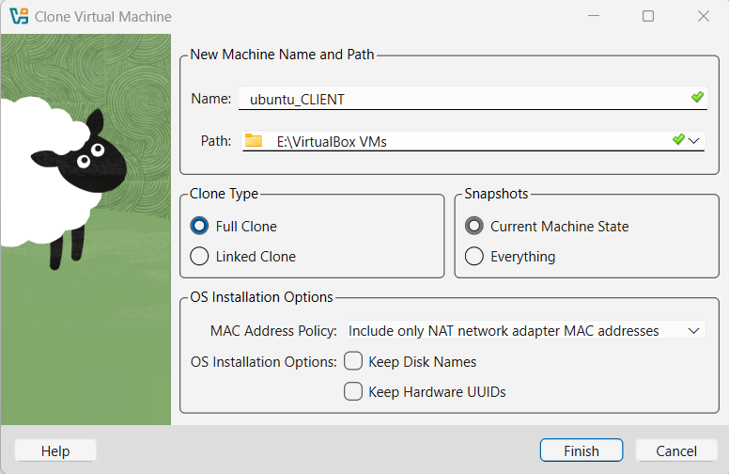
Step 2: Check IP Address
Command: ip a
Step 3: Create Server Program
File Name: server.py
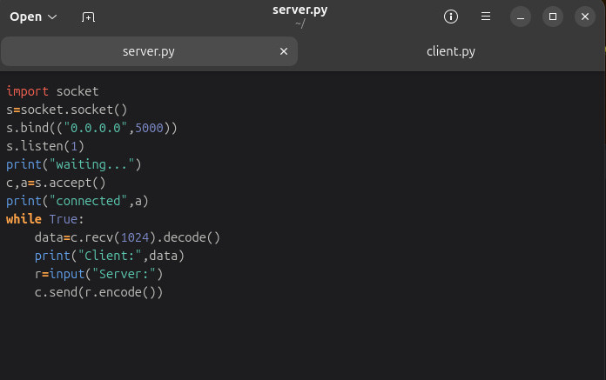
Step 4: Create Client Program
File Name: `client.py`
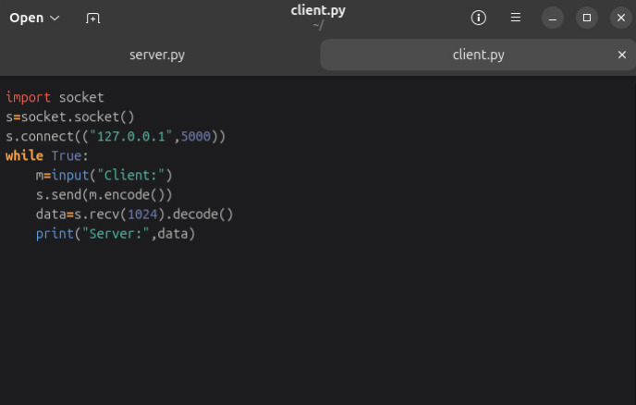

Step 5: Run the Programs
Open 2 terminals.
Terminal 1 (Server):
python3 server.py
Terminal 2 (Client):
python3 client.py
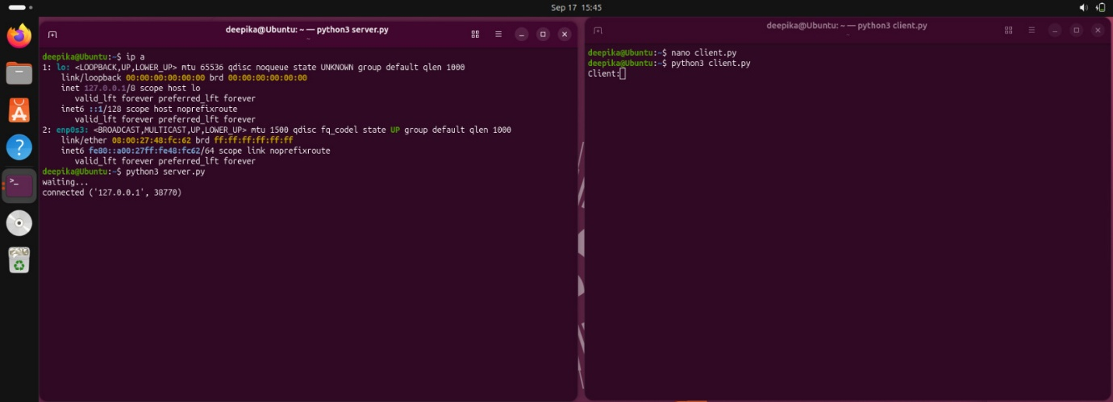
Output:
- Server Terminal shows: Client: hello!
- Client Terminal shows: Server: hii
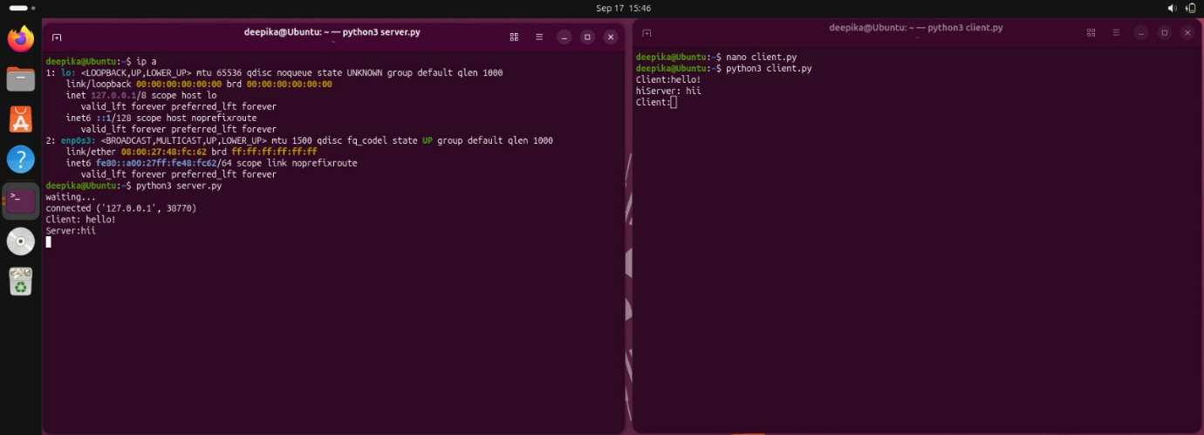
Step 6: Stop
Press Ctrl+ C to stop both.

RESULT: Successfully implemented TCP client-server communication using Python sockets. Message exchange between client and server was successful.

CONCLUSION: We learned socket programming and how two programs communicate over a network using IP address and port number.

